set.pop()
Remove and return an arbitrary element from the set. Raises KeyError if the set is empty.

>>> A={10,20,30,40,50}
>>> print(A)
{50, 20, 40, 10, 30}
>>> x=A.pop()
>>> print(x)
50
>>> print(A)
{20, 40, 10, 30}
>>> y=A.pop()
>>> print(y)
20
>>> print(A)
{40, 10, 30}
>>> B=set()
>>> B.pop()
Traceback (most recent call last):
File "<pyshell#9>", line 1, in <module>
B.pop()
KeyError: 'pop from an empty set'

Mathematical set operations
set.union(*others)
set | other | ...
Return a new set with elements from the set and all others.

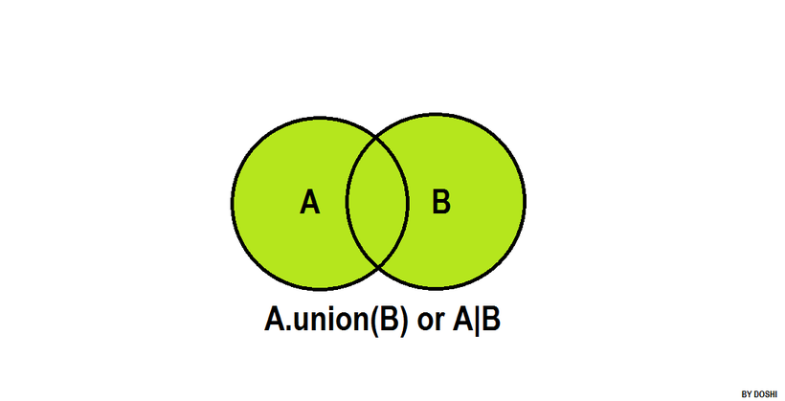
>>> A={10,20,30,40}
>>> B={50,60,70,80}
>>> C=A.union(B)
>>> print(A,B,C,sep="\n")
{40, 10, 20, 30}
{80, 50, 60, 70}
{70, 40, 10, 80, 50, 20, 60, 30}
>>> D=A|B
>>> print(D)
{70, 40, 10, 80, 50, 20, 60, 30}
>>> S1={1,2,3,4,5}
>>> L1=[1,2,3,6,7]
>>> S2=S1.union(L1)
>>> print(S1,L1,S2,sep="\n")
{1, 2, 3, 4, 5}
[1, 2, 3, 6, 7]
{1, 2, 3, 4, 5, 6, 7}

https://www.hackerrank.com/challenges/py-set-union/problem?isFullScreen=false

n=int(input())
eng=set(map(int,input().split()))
b=int(input())
fr=set(map(int,input().split()))
eng_fr=eng.union(fr)
print(len(eng_fr))

set.intersection(*others)
set & other & ...
Return a new set with elements common to the set and all others.

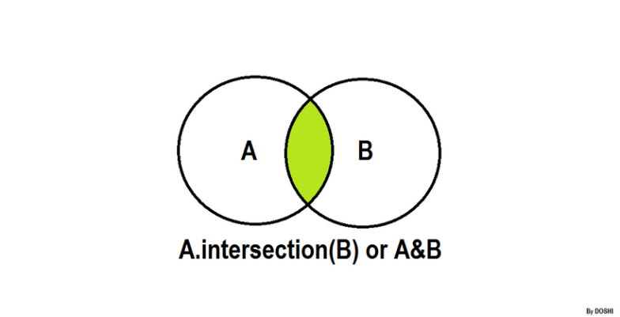
>>> A={1,2,3,4,5}
>>> B={1,2,3,6,7}
>>> C=A.intersection(B)
>>> print(A,B,C)
{1, 2, 3, 4, 5} {1, 2, 3, 6, 7} {1, 2, 3}
>>>java_student={'naresh','ramesh','kishore','raman'}
>>> python_student={'ramesh','rajesh','raman','kiran'}
>>> print(java_student)
{'kishore', 'ramesh', 'naresh', 'raman'}
>>> print(python_student)
{'ramesh', 'rajesh', 'raman', 'kiran'}
>>> java_python=java_student&python_student
>>> print(java_python)
{'ramesh', 'raman'}
>>>
>>> A={1,2,3}
>>> B={1,2,4,5}
>>> C={2,3,5,6}
>>> D=A&B&C
>>> print(A)
{1, 2, 3}
>>> print(B)
{1, 2, 4, 5}
>>> print(C)
{2, 3, 5, 6}
>>> print(D)
{2}

set.difference(*others)
set - other - ...
Return a new set with elements in the set that are not in the others.
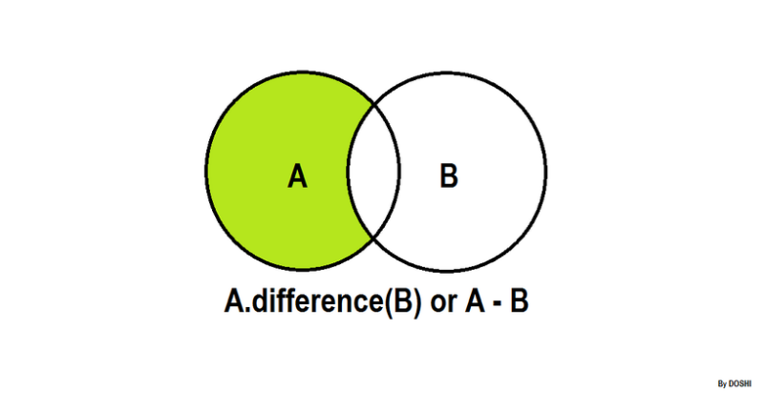

>>> A={1,2,3,4,5,6,7,8}
>>> B={1,6,7,2}
>>> C=A.difference(B)
>>> print(A)
{1, 2, 3, 4, 5, 6, 7, 8}
>>> print(B)
{1, 2, 6, 7}
>>> print(C)
{8, 3, 4, 5}
>>> python_stud={'naresh','ramesh','kishore','raman'}
>>> java_stud={'kiran','raman','rajesh','naresh'}
>>> print(python_stud)
{'naresh', 'kishore', 'raman', 'ramesh'}
>>> print(java_stud)
{'naresh', 'kiran', 'raman', 'rajesh'}
>>> only_python=python_stud.difference(java_stud)
>>> print(only_python)
{'kishore', 'ramesh'}
>>> only_java=java_stud-python_stud
>>> print(only_java)
{'kiran', 'rajesh'}

set.symmetric_difference(other, /)
set ^ other
Return a new set with elements in either the set or other but not both.

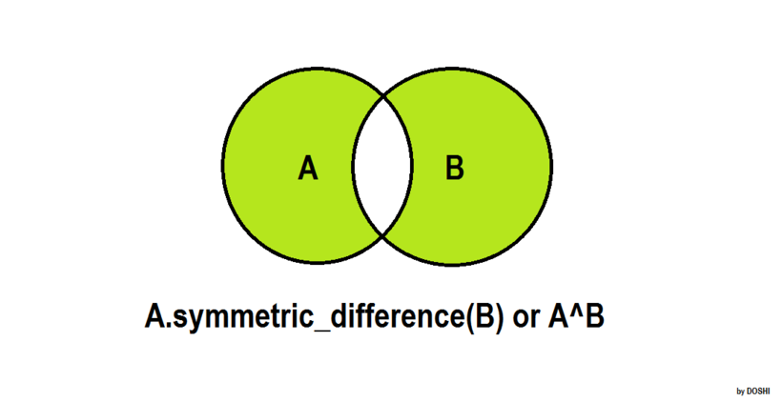

>>> A={1,2,3,4,5}
>>> B={1,2,3,6,7}
>>> C=A.symmetric_difference(B)
>>> print(A,B,C,sep="\n")
{1, 2, 3, 4, 5}
{1, 2, 3, 6, 7}
{4, 5, 6, 7}
>>> D=A^B
>>> print(D)
{4, 5, 6, 7}

https://www.hackerrank.com/challenges/py-set-symmetric-difference-operation/problem?isFullScreen=false

n=int(input())
eng=set(map(int,input().split()))
b=int(input())
fr=set(map(int,input().split()))
print(len(eng.symmetric_difference(fr)))

Mathematical set mutable operations
set.update(*others)
set |= other | ...
Update the set, adding elements from all others.

>>> A={1,2,3,4,5}
>>> B={1,2,3,6,7,8}
>>> print(A)
{1, 2, 3, 4, 5}
>>> print(B)
{1, 2, 3, 6, 7, 8}
>>> A.update(B)
>>> print(A)
{1, 2, 3, 4, 5, 6, 7, 8}
>>> S1={1,2,3}
>>> S2={4,5,6}
>>> S1|=S2
>>> print(S1)
{1, 2, 3, 4, 5, 6}

set.intersection_update(*others)
set &= other & ...
Update the set, keeping only elements found in it and all others.

>>> A={1,2,3,4}
>>> B={1,3,5,6}
>>> print(A)
{1, 2, 3, 4}
>>> print(B)
{1, 3, 5, 6}
>>> A.intersection_update(B)
>>> print(A)
{1, 3}
>>> X={1,2,3}
>>> Y={1,2,5,6}
>>> X&=Y
>>> print(X)
{1, 2}

set.difference_update(*others)
set -= other | ...
Update the set, removing elements found in others.

>>> A={1,2,3,4,5,6,7,8,9}
>>> B={1,6,3,8,10,12}
>>> print(A)
{1, 2, 3, 4, 5, 6, 7, 8, 9}
>>> print(B)
{1, 3, 6, 8, 10, 12}
>>> A.difference_update(B)
>>> print(A)
{2, 4, 5, 7, 9}
>>> X={1,2,3,4,5}
>>> Y={1,5,7,8}
>>> X-=Y
>>> print(X)
{2, 3, 4}

set.symmetric_difference_update(other, /)
set ^= other
Update the set, keeping only elements found in either set, but not in both.

>>> A={1,2,3,4,5}
>>> B={1,3,4,6,7}
>>> print(A)
{1, 2, 3, 4, 5}
>>> print(B)
{1, 3, 4, 6, 7}
>>> A.symmetric_difference_update(B)
>>> print(A)
{2, 5, 6, 7}

Set examine methods

set.isdisjoint(other, /)
Return True if the set has no elements in common with other. Sets are disjoint if and only if their intersection is the empty set.

>>> A={1,2,3,4,5}
>>> B={6,7,8,9,10}
>>> A.isdisjoint(B)
True
>>> C={1,2,8,9,10}
>>> A.isdisjoint(C)
False

set.issubset(other, /)
set <= other
Test whether every element in the set is in other.

>>> A={1,2,3,4,5}
>>> B={1,2,3,4,5,6,7,8,9,10}
>>> A.issubset(B)
True
>>> B={1,2,3,6,7,8}
>>> A.issubset(B)
False
>>> A<=B
False

set.issuperset(other, /)
set >= other
Test whether every element in other is in the set.

>>> A={1,2,3,4,5,6,7,8,9,10}
>>> B={1,7,9,4,5}
>>> A.issuperset(B)
True
>>> C={1,2,3,4,20,30}
>>> A.issuperset(C)
False
>>> A>=B
True
>>> A>=C
False

>>> A={{1,2},{3,4}}
Traceback (most recent call last):
File "<pyshell#68>", line 1, in <module>
A={{1,2},{3,4}}
TypeError: cannot use 'set' as a set element (unhashable type: 'set')

frozenset
frozenset is an immutable set.
After creating frozenset changes cannot done (OR) frozenset does not support mutable operations.

In application development frozenset is used,
- For representing immutable set
- For representing set inside set(nested sets)
How to create frozenset?
- frozenset() : create empty frozenset
- frozenset(iterable): create frozenset using elements of existing collections or iterables

>>> fs1=frozenset()
>>> print(fs1)
frozenset()
>>> fs1.add(10)
Traceback (most recent call last):
File "<pyshell#71>", line 1, in <module>
fs1.add(10)
AttributeError: 'frozenset' object has no attribute 'add'
fs1=frozenset()
>>> print(fs1)
frozenset()
>>> fs1.add(10)
Traceback (most recent call last):
File "<pyshell#71>", line 1, in <module>
fs1.add(10)
AttributeError: 'frozenset' object has no attribute 'add'
>>> fs2=frozenset(range(10,110,10))
>>> print(fs2)
frozenset({100, 70, 40, 10, 80, 50, 20, 90, 60, 30})
>>> fs3=frozenset("PYTHON")
>>> print(fs3)
frozenset({'O', 'T', 'P', 'N', 'Y', 'H'})
>>> fs4=frozenset([10,20,30,40,50])
>>> print(fs4)
frozenset({40, 10, 50, 20, 30})

Example of nested sets
A={frozenset(range(1,6)),frozenset(range(10,60,10))}
print(A)
for x in A:
print(x)

for x in A:
for y in x:
print(y,end=' ')
print()

Output
{frozenset({1, 2, 3, 4, 5}), frozenset({40, 10, 50, 20, 30})}
frozenset({1, 2, 3, 4, 5})
frozenset({40, 10, 50, 20, 30})
1 2 3 4 5
40 10 50 20 30

